Nick Videtti

NetID: nvidetti

IST 722 - Data Warehouse

Assignment 1

1/16/2023

| **TABLE** | **TYPE** | **# ROWS** | **PK(s) USED** | **ONE ROW IS** |
| --- | --- | --- | --- | --- |
| Employees | Master Data | 9 | EmployeeID | An employee |
| EmployeeTerritories | Business Process | 49 | EmployeeID, TerritoryID | An employee assigned to a territory |
| Customers | Master Data | 91 | CustomerID | A customer |
| Suppliers | Master Data | 29 | SupplierID | A supplier |
| Products | Master Data | 77 | ProductID | A product |
| Shipments (of Orders) | Business Process | 830 | OrderID | An order |
| Details (of an Order) | Business Process | 2155 | OrderID,  ProductID | A product that was ordered with its corresponding order |

**Queries for Customers table Data Profiling**

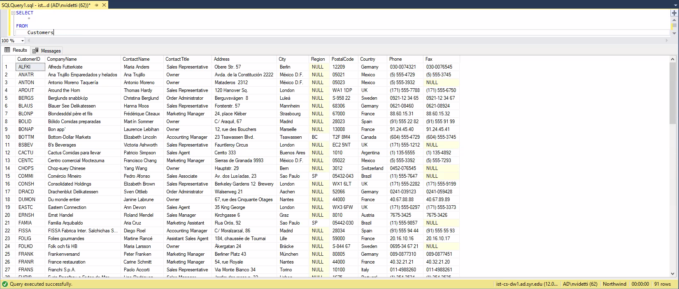

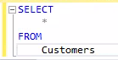 

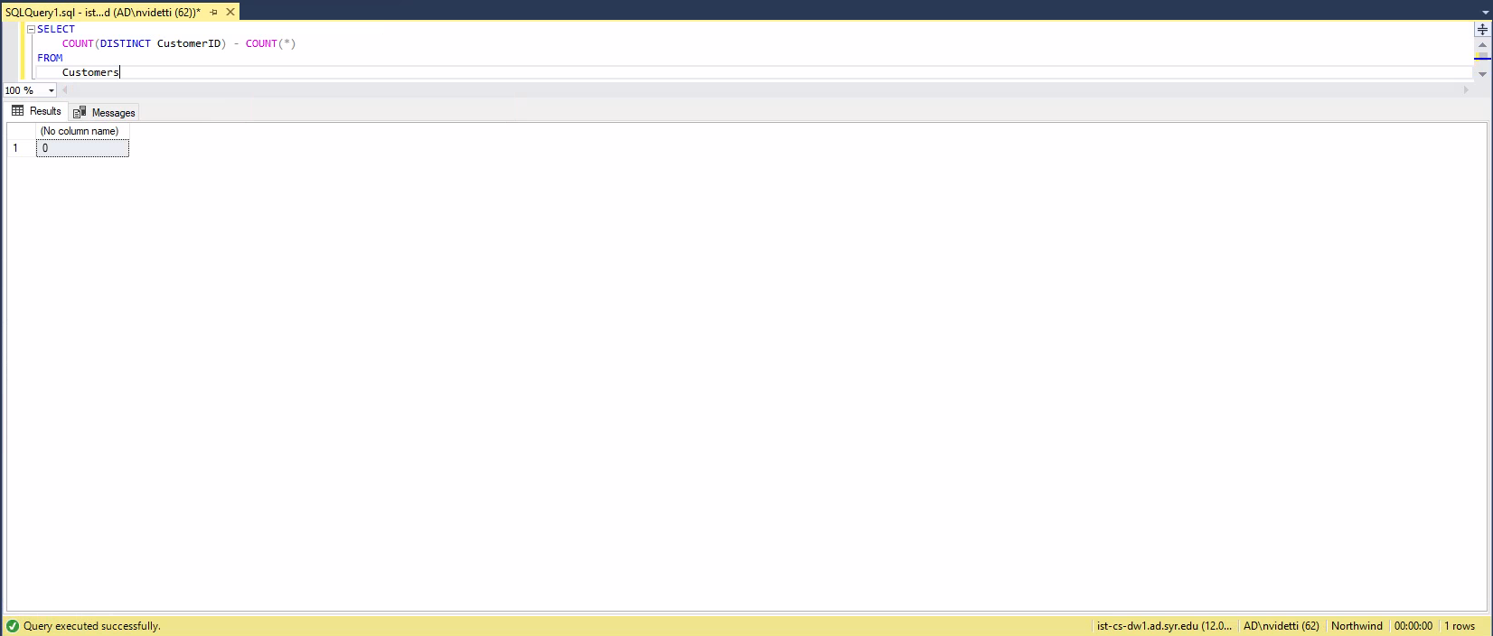

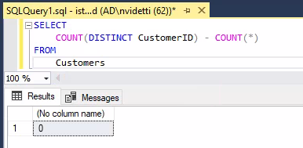



**Queries for Suppliers table Data Profiling**

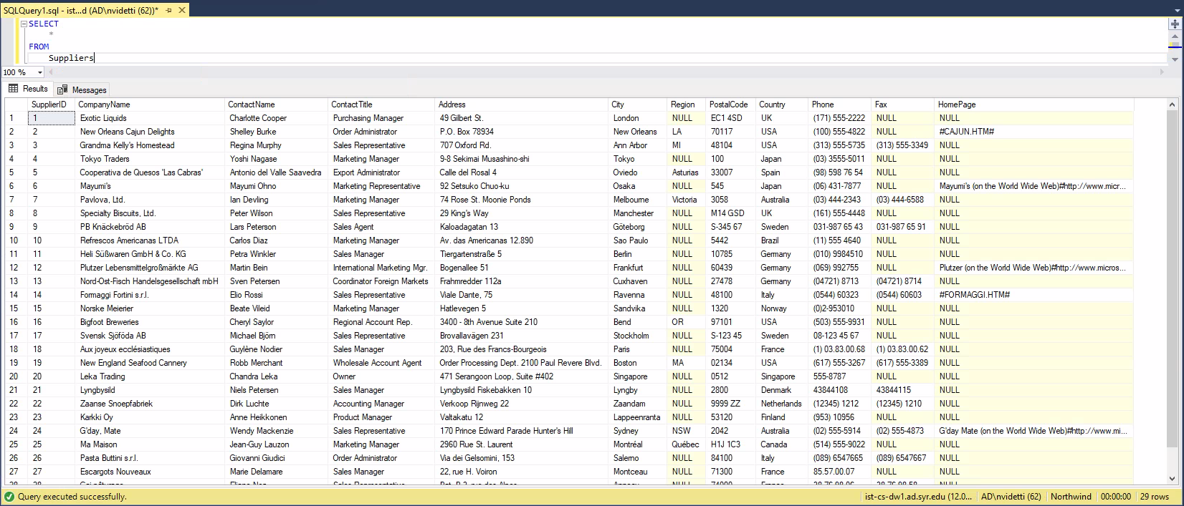

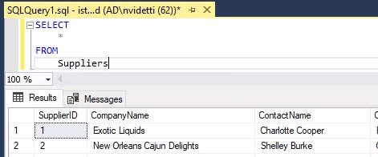



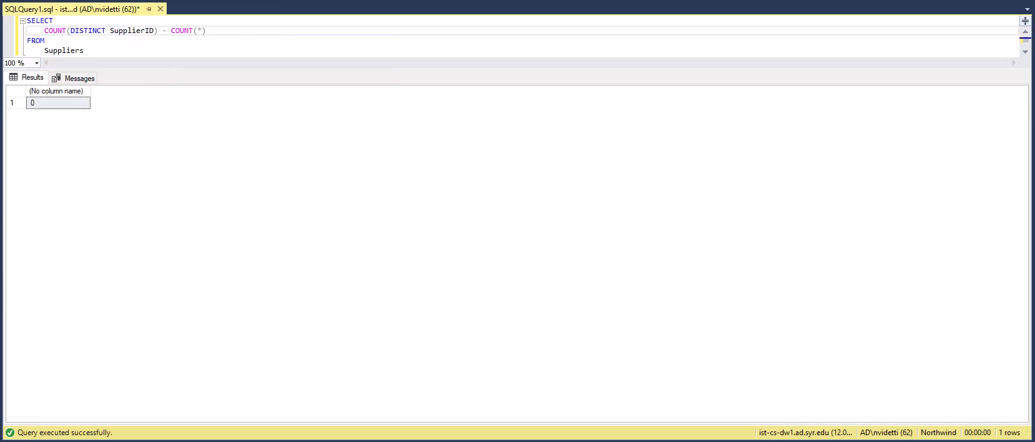

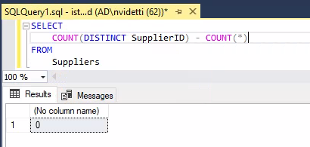



**Queries for Products table Data Profiling**

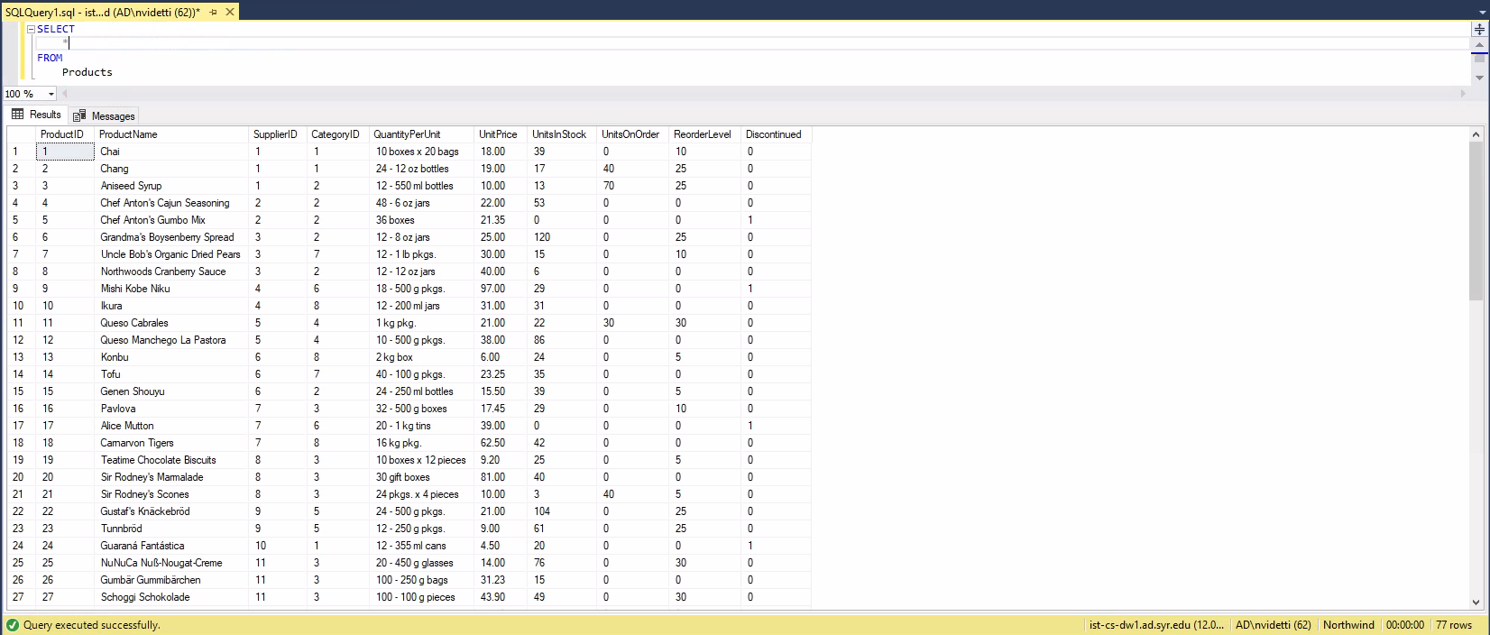

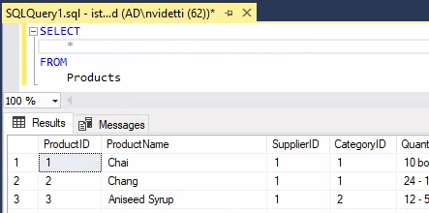



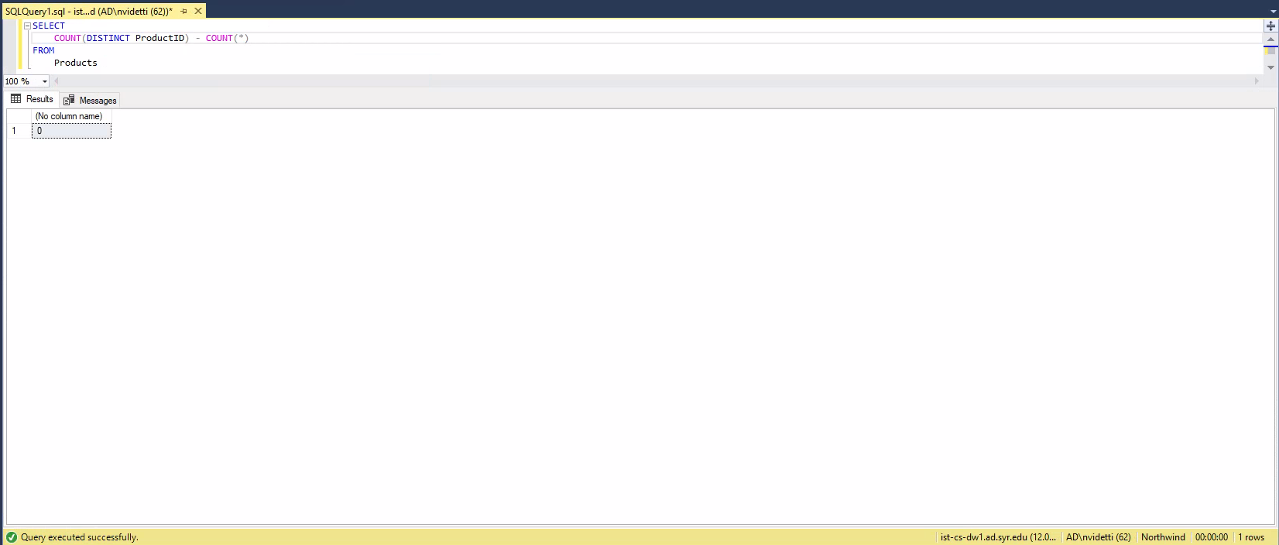

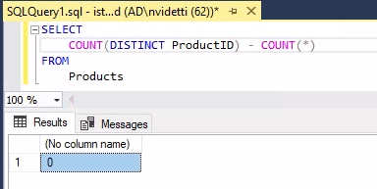



**Queries for Orders table Data Profiling**

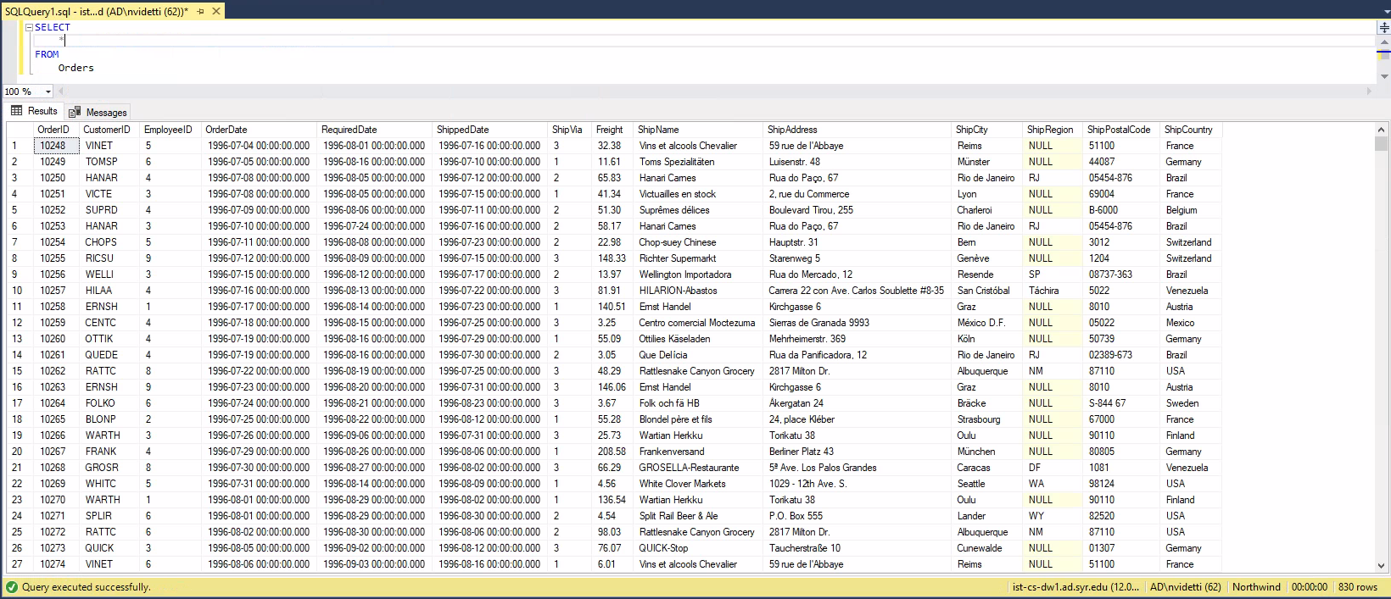

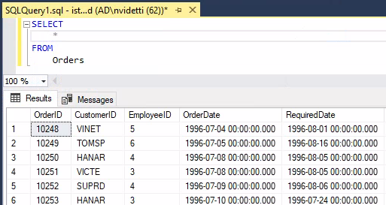



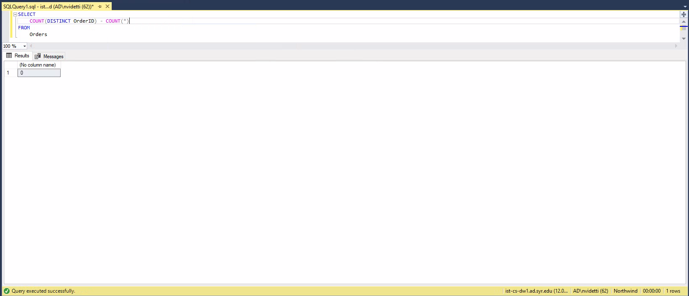

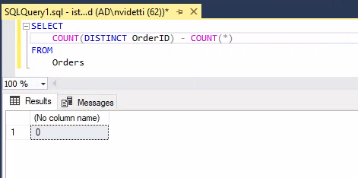



**Queries for Order Details table Data Profiling**

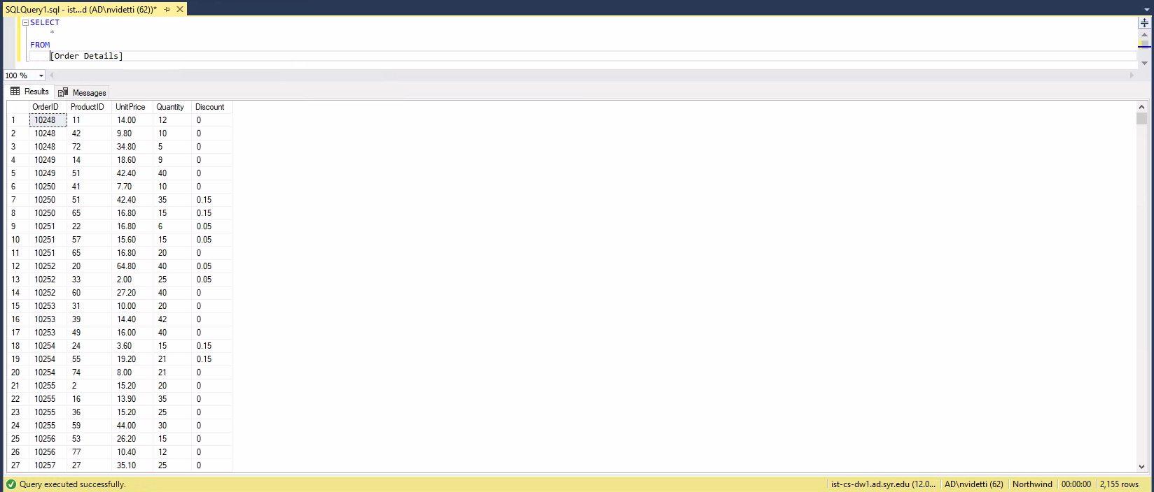

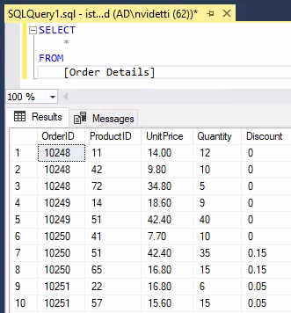



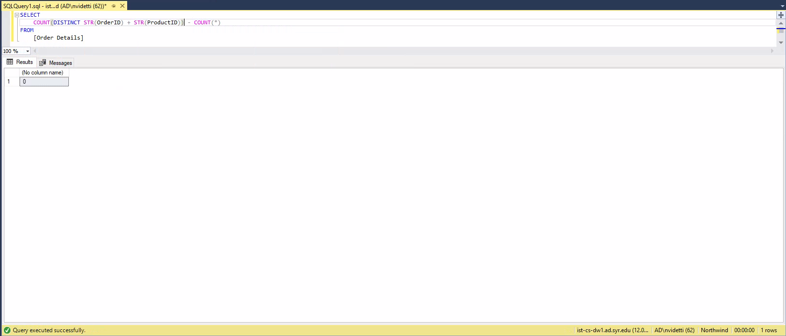

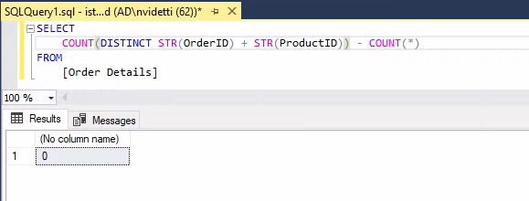



**1. List the customer contact names and titles sorted by company name.**

*SELECT*

*CompanyName Company,*

*ContactName Contact,*

*ContactTitle Title*

*FROM*

*Customers*

*ORDER BY*

*CompanyName ASC*

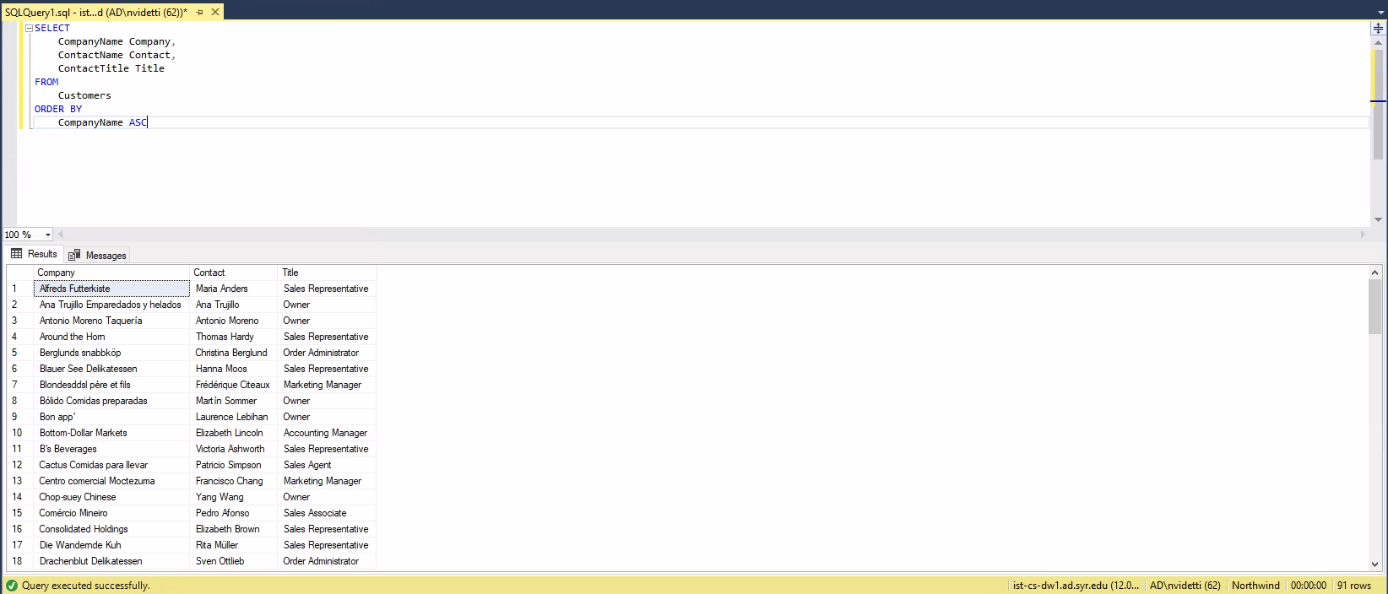

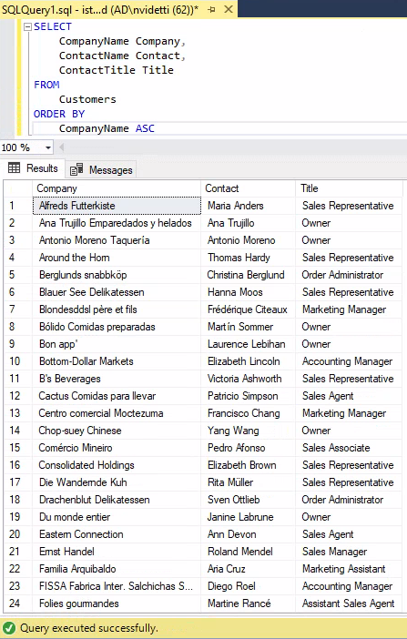



**2. Factoring in discounts, what is total amount of product sold?**

*SELECT*

*ROUND(SUM(UnitPrice*(1-Discount)*Quantity),2) "Total Revenue"*

*FROM*

*[Order Details]*

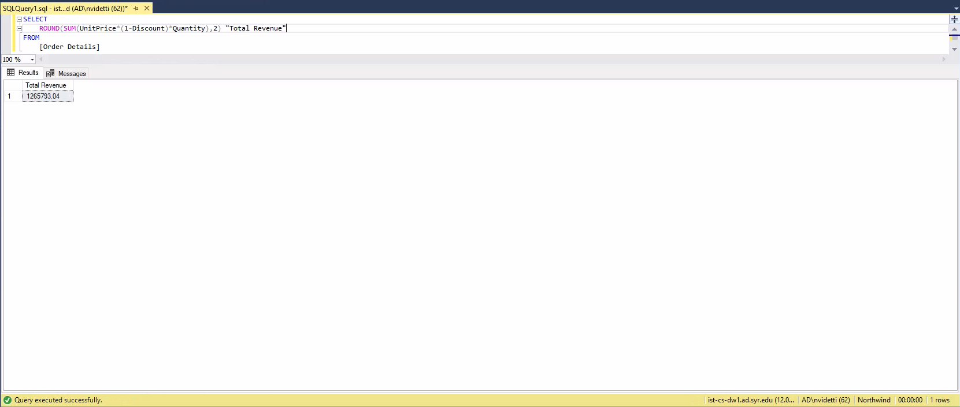

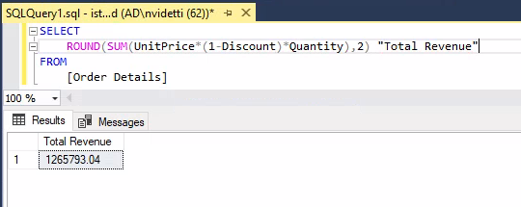



**3. Provide a list of product category names with counts of products in each category.**

*SELECT*

*Categories.CategoryName Category,*

*COUNT(DISTINCT Products.ProductID) Products*

*FROM*

*Categories*

*LEFT JOIN*

*Products*

*ON Categories.CategoryID = Products.CategoryID*

*GROUP BY*

*Categories.CategoryName*

*ORDER BY*

*Products DESC*

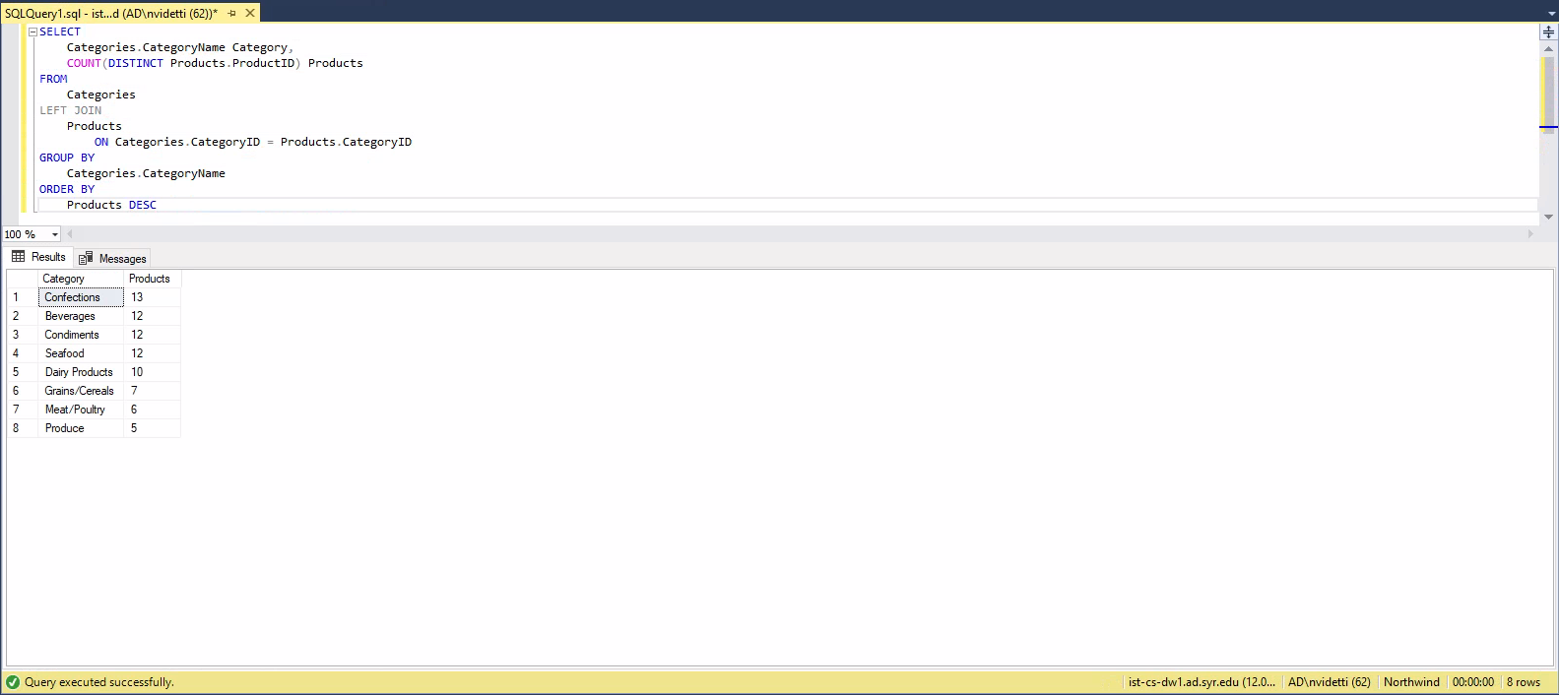

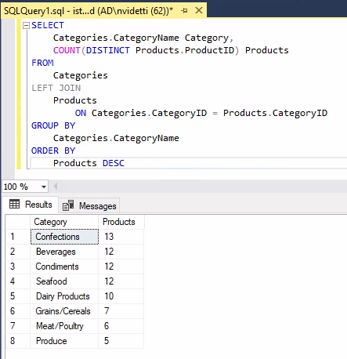



**4. Select a specific customer, and display that customer’s orders with total amount of product sold for each order.**

*SELECT*

*O.OrderID "Order",*

*SUM(OD.Quantity) "Quantities Sold",*

*ROUND(SUM(OD.UnitPrice*(1-OD.Discount)*OD.Quantity),2) Revenue*

*FROM*

*Orders O*

*LEFT JOIN*

*[Order Details] OD*

*ON O.OrderID = OD.OrderID*

*WHERE*

*O.CustomerID = 'BSBEV'*

*GROUP BY*

*O.OrderID*

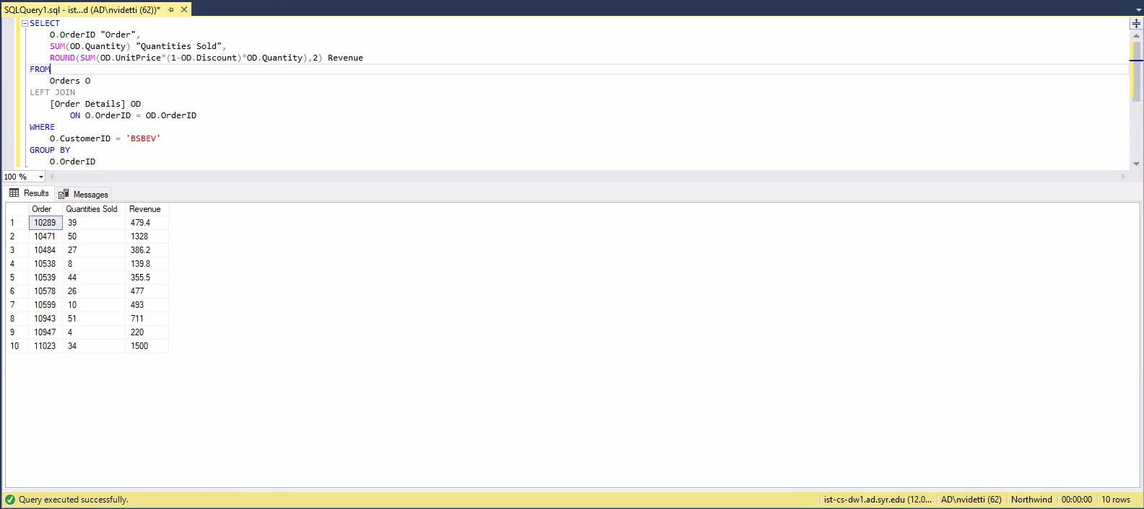

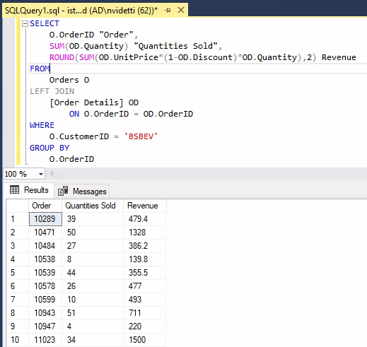



**5. Select a specific employee and each order, how it was shipped (shipvia), the company who shipped it, and the total number of days elapsed from order date to shipped date.**

*SELECT*

*O.OrderID "Order",*

*S.CompanyName Shipper,*

*DATEDIFF(day,O.OrderDate,O.ShippedDate) "Days to Ship"*

*FROM*

*Orders O*

*LEFT JOIN*

*Shippers S*

*ON O.ShipVia = S.ShipperID*

*WHERE*

*O.EmployeeID = 1*

